Report Title: Using the ADC and display the result on the

Unit Name: Mechatronic Systems Programming I

Unit Code: EMT 3104

Group No: 1

Group Members:

- E022-01-0765/2019 - JEREMIAH KIARIE
- E022-01-0773/2019 - STEPHEN MUSANGI
- E022-01-0812/2019 - ERICK SAHA
- E022-01-1998/2019 - RUTH MBUGUA
- E022-01-0789/2019 - ELVIS KIPNGETICH
- E022-01-0817/2019 - DISHAN OTIENO
- E022-01-0794/2019 - NEWTON KARIUKI
- E022-01-0781/2019 - KEVIN KIPKORIR

Submission Date: 13th September 2021

INTRODUCTION

- Analog Digital Converter
The Analog Digital Converter (ADC) translates an analog input signal to a digital output value representing the size of the input relative to a reference .It is generally needed whenever we deal with a sensor that produces an analog output (for example: LM35 temperature sensor), which is the case for a wide range of sensors. When dealing with such sensors we have to convert the analog signal coming out of them into digital words of ones and zeros so that our micro-controller can process it and make decisions based on it. The Atmega32 controller has this device built-in.
The ADC can be operated in:

- Single conversion
- Free running mode.

In single conversion mode the ADC does the conversion and then stop while in free it is continuously converting. It does a conversion and then start next conversion immediately after that.

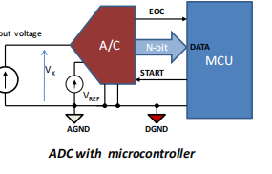
ADC
ADC Reference Voltage
The reference voltage is the maximum voltage you are expecting to receive from the sensor on the input channel of the ADC.
In Atmega32 you can use one of three sources for the reference voltage:
- An internal voltage from within the Atmega32 MCU. This voltage is set to 2.56V and cannot be changed.
- The AVCC pin can be your reference voltage, but this pin must be connected to the VCC and in this case, your reference voltage is the VCC
- Finally, you can use your own customized reference voltage by connecting a voltage source that has the same value as the reference voltage you want to the pin AREF (pin32).
Choosing between these three sources of reference voltage happens while configuring the ADMUX register.

Atmega32 ADC Input Channels
ADC of the Atmega32 can accept inputs from up to eight channels. This means that you can connect up to eight analog input signals to the Atmega32 ADC, but at each conversion, only one channel input is converted. So, at each conversion, you should first choose the input channel to convert before starting the conversion. This is also done in the ADMUX register.
The input channels are multiplexed over the pins of port A of the ATmega32. These are the pins (33 to 40).
The Analog to Digital Converter (ADC) module located within the Amega32 micro-controller has a resolution of ten-bit length. A 10 Bit ADC has a range of 0-1023 (1023 steps).
Step size is the smallest input voltage that can be read by the ADC.
• Step size with Vref = 5V : 5/1023 = 4.88 mV.
• Step size with Vref = 2.56 : 2.56/1023 = 2.5 mV.
Digital data output = Input Voltage/ step size.
Hardware Requirements
Before using the ADC of the Atmeg32 there are a few hardware connections required in the circuit so that you can get the best results:
- You should make sure that pins (VCC & AVCC) that are pins (10 & 30) are connected. This is because the ADC gets its power supply from the AVCC pin.
- If conversion accuracy is critical all the time, it is preferable that you connect a coil between the 2 pins and a capacitor between AVCC and GND. These 2 connections make the supply voltage of the ADC more stable and not easily fluctuated by noise.
- Also, it is preferable to connect a capacitor between AREF and GND so that the reference voltage of the ADC is more stable and not affected by noise. (Even if you choose to use the internal voltage or the AVCC)
Resolution
ADC resolution is the number of bits used to represent the analog input signal. To more accurately replicate the analog signal, you must increase the resolution. Using an ADC with higher resolution also reduces the quantization error.
Conversion Time
This is the time required for ADC to convert each analog level to its digital format.

ADC Registers
Registers related to any particular peripheral module provides the communication link between the CPU and that peripheral. You configure the ADC according to need using these registers and you also get the conversion result also using appropriate registers.
The ADC has only four registers.
- ADC Multiplexer Selection Register (ADMUX) - for selecting the reference voltage and the input channel.
- ADC Control and Status Register A (ADCSRA) - it has the status of ADC and is also use for controlling it.
- The ADC Data Register ADCL and ADCH - the final result of conversion is here.

- 7-Segment display
The 7-segment display consists of seven LEDs arranged in a rectangular fashion as shown below. Each of the seven LEDs is called a segment because when illuminated the segment forms part of a numerical digit (both Decimal and Hex) to be displayed. An additional 8th LED is sometimes used within the same package thus allowing the indication of a decimal point when two or more 7-segment displays are connected together to display numbers greater than ten.

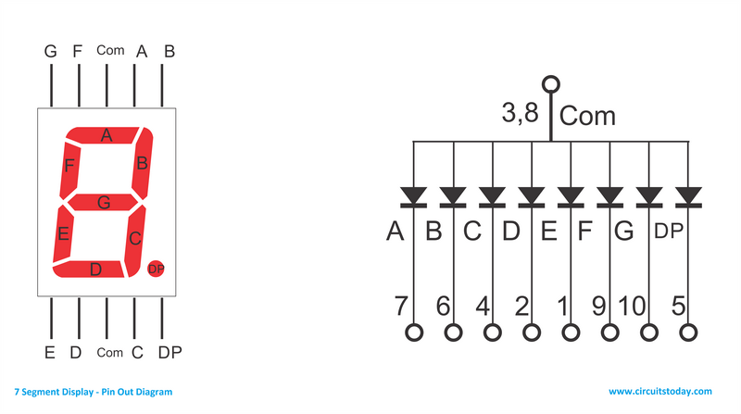

Each one of the seven LEDs in the display is given a positional segment with one of its connection pins being brought straight out of the rectangular plastic package. These individually LED pins are labeled from “a” through to “g” representing each individual LED. The other LED pins are connected together and wired to form a common pin.
So by forward biasing the appropriate pins of the LED segments in a particular order, some segments will be light and others will be dark allowing the desired character pattern of the number to be generated on the display. This then allows us to display each of the ten decimal digits 0 through to 9 on the same 7-segment display.

The displays common pin is generally used to identify which type of 7-segment display it is. As each LED has two connecting pins, one called the “Anode” and the other called the “Cathode”, there are therefore two types of LED 7-segment display called:
- Common Cathode (CC)
- Common Anode (CA)

The Common Cathode (CC)
In the common cathode display, all the cathode connections of the LED segments are joined together to logic “0” or ground. The individual segments are illuminated by application of a “HIGH”, or logic “1” signal via a current limiting resistor to forward bias the individual Anode terminals (a-g).
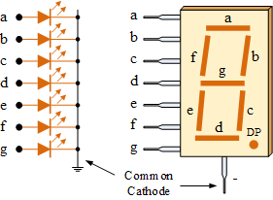
The Common Anode (CA)
In the common anode display, all the anode connections of the LED segments are joined together to logic “1”. The individual segments are illuminated by applying a ground, logic “0” or “LOW” signal via a suitable current limiting resistor to the Cathode of the particular segment (a-g).
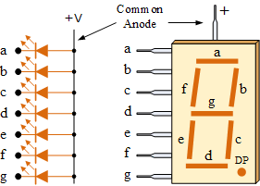

METHODOLOGY
1. Configure the ADC module:
- Configure analog pins/voltage reference (ADMUX)
- Select ADC input channel (ADMUX)
- Select ADC conversion clock- prescaler (ADCSRA)
- Turn on ADC module, bit ADEN (ADCSRA)
- Configure ADC interrupt (if desired).
3. Start conversion:
- Set bit ADSC (ADCSRA)
4. Wait for ADC conversion to complete, by either:
- Checking for the ADIF bit; OR
- Waiting for the ADC interrupt
5. Read ADC result register pair (ADCL and ADCH), clear bit ADIF if required.
6. For the next conversion, go to step 1 or step 2, as required.

Circuit Components
- 2 digit seven segment display
- 10k variable resistor
- Arduino UNO
- Connecting wire
- Breadboard
- Computer for uploading the software.

Circuit Diagram
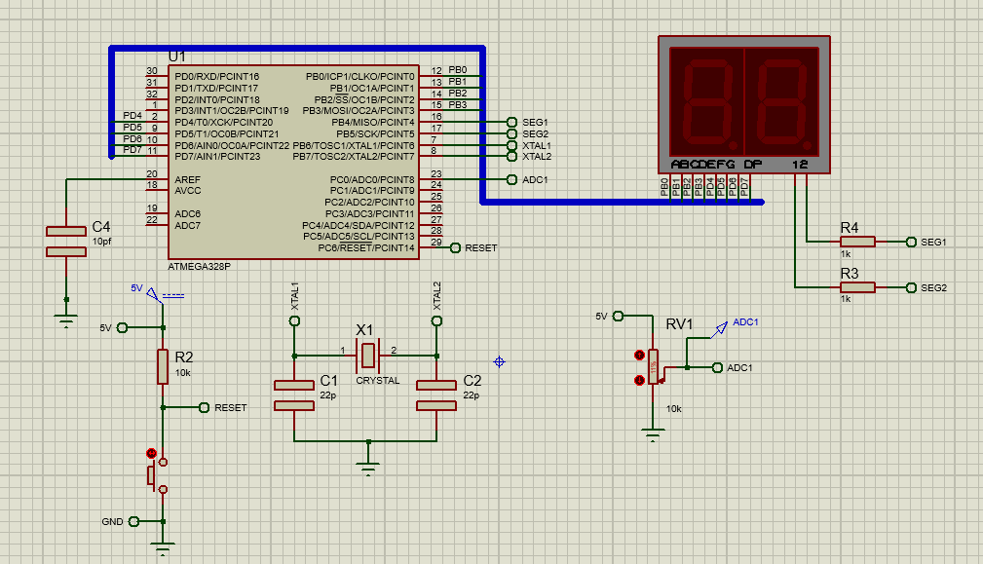

Flow chart
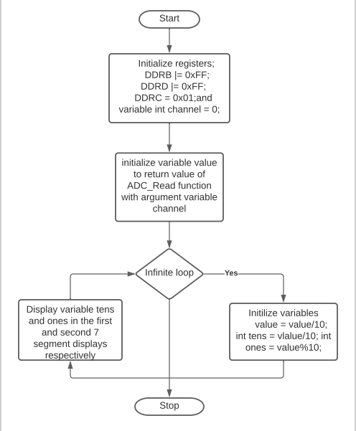

C program
#define F_CPU 16000000UL

#include <avr/io.h>
#include <avr/interrupt.h>
#include <util/delay.h>

volatile static uint8_t adc_convert_done = 1;

int SEG1 = 4;
int SEG2 = 5;
char display[] = {0x3F ,0x06, 0x5B, 0x4F, 0x66, 0x6D, 0x7D, 0x07, 0x7F, 0x67};

// A function to act as a persistence of vision delay
void vision_persist(){
int delay = 7;
while (0 < delay){
_delay_ms(1);
--delay;
}
}

// Function to initialize ADC
void InitADC(){
// Select Vref=AVcc
ADMUX = ADMUX | (0<<REFS0) | (0<<REFS1);
//set prescaler to 128 and enable ADC
ADCSRA |= (1<<ADPS2)|(1<<ADPS1)|(1<<ADPS0)|(1<<ADEN);
}

// Function to set ADC input pin
void adc_pin_enable(uint8_t pin){
DIDR0 |= (1 << pin);
}

// Function to read analogue input from the potentiometer
uint16_t ReadADC(uint8_t ADCchannel){
//select ADC channel with safety mask
ADMUX = (ADMUX & 0xF0) | (ADCchannel & 0x0F);
//single conversion mode
ADCSRA |= (1<<ADSC);
// wait until ADC conversion is complete
while( ADCSRA & (1<<ADSC) );
return ADC;
}

void displayLED(int input){ /*Function to display a number in the LED*/
char BH = (~PORTB & 0xF0);
char BL = (display[input] & 0x0F);
PORTB = ~(BH|BL);

char DL = (~PORTD & 0x0F);
char DH = (display[input] & 0xF0);
PORTD = ~(DH|DL);
}

// ADC interrupt Service Routine
ISR(ADC_vect){
while ((ADCSRA & 0x01) == 1);
ADCSRA &= ~0x01; //Clear ADC flag
}

int main(void)
{

DDRB = 0xff;
DDRD = 0xff;
DDRC = 0x01;
PORTB |= (1 << SEG1);
uint16_t value;
uint8_t ADCchannel = 0;
InitADC();
sei();

int ones, tens;
while (1){
value = ReadADC(ADCchannel);
tens = value/10;
ones = value%10;
PORTB ^= (1<<SEG1); /* Toggle SEG1 */
PORTB ^= (1<<SEG2); /* Toggle SEG2 */
displayLED(tens);
vision_persist();

PORTB ^= (1<<SEG1); /* Toggle SEG1 */
PORTB ^= (1<<SEG2); /* Toggle SEG2 */
displayLED(ones);
vision_persist();
}
}

DISCUSSION
The program reads a varying voltage. The varying voltage is provided by varying the variable resistor. It is then scaled between values from 0 to 99 and displayed on the 2 digit 7 segment LED display. This is implemented by connecting the Proteus circuit above and loading the code above in the micro controller after which the variable resistor is varied to observe the results. By varying the variable resistor it is seen that the value displayed on the 2 digit 7 segment display ranges from 0 to 99.

CONCLUSION
It can be concluded that with ADC, analog inputs from sensors and other devices such as a variable resistor can be converted to digital signals, after which this digital signals can be processed by a microcontrollers such as displaying the signal in a 7 segment display. This is because microcontrollers are capable of processing only digital signals. Thus, ADC acts as an interface between a sensor and other devices such as a potentiometer and a microcontroller.

REFERENCES

- Steven F. Barret. Embedded Systems Design with the Atmel AVR Microcontroller. Morgan and Claypool Publishers.
- Atmega32 Datasheet.

